

ENGR-111-Engineering Design

Section 51 - Group F
Duster for Inaccessible Surfaces
Nelson King

Lamya Alameeri 1089

Alyazia Alrashed 0625

Khawla Almujaini 9495

Mariam Almarzooqi

Shaikha Alabdouli 9479

Instructor name:

Abdessamia Jebbouri

Spring 2018

Table of Content
Table of Contents
ENGR-111-Engineering Design 1
Section 51 - Group F 1
Lamya Alameeri 1089 1
Alyazia Alrashed 0625 1
Khawla Almujaini 9495 1
Mariam Almarzooqi 1
Shaikha Alabdouli 9479 1
Instructor name: 1
Abdessamia Jebbouri 1
Spring 2018 1
Table of Content 2
1.0 Executive Summary 3
1.01 The concept of our project 3
1.02 Proposed Solution 3
1.03 Test Results 3
1.04 Future Developments 3
2.0 Problem Statement 4
3.0 Proposed Approach 4
3.01 Characteristics 4
3.02 Design methodology 4
3.03 Final Design 5
4.0 Implementation 5
4.01 Team Charter 6
4.011 Purpose Statement and team objectives 6
4.013 Strengths 6
4.014 Development Needs 7
4.015 Functional roles 7
4.016 Team Process Management 7
4.017 Decision Making Process 8
4.018 Process Roles 8
4.019 Team Expectations 8
4.0110 Assessment of Team Success 9
5.0 Testing Results 9
6.0 Discussion 9
7.0 Conclusion 10

1.0 Executive Summary
Most cleaners often use mops with long poles to clean tall buildings. However, there is a limitation to the extent in which they dust the dirt. Even when vertical ribs would have eased the motion, the extent of reach will still be limited.

1.01 The concept of our project
The project’s concept is to design and come up with a way of cleaning surfaces on higher levels. It is assumed that cleaners will work together and can assign themselves to different floors.

1.02 Proposed Solution
A designed machine that has 3 cleansers in 1. The three cleansers are connected at the top by a brand new triple water pump (typically used in gardens). It can be extended to 3 meters and at least 1 meter in height. The long iron stick which is flexible in its length was obtained from the construction materials shop and the iron stick was welded to aid its connection with the steam iron. In addition, the top of the machine can be rotated without a demo (one which can rotate automatically). The machine contains steam to make the selected cleansers wet and easy to clean the shelves and tall buildings. Further, it has a feather broom for sweeping dirty areas. The bottom of the machine is a domestic steam iron box obtained locally.

1.03 Test Results
After testing the machine during class, it functioned as expected, though it was a bit challenging to move it with the electric cable and hard to rotate it in high levels.

1.04 Future Developments
For future developments, we will make use of the automatic demo for rotating and a durable battery in the machine to ease its movement in high surfaces and roofs.

2.0 Problem Statement
Accessing tall buildings when cleaning has been a great challenge to most cleaners. There are some areas that are not easily accessed. The purpose of this project is to device a duster for inaccessible surfaces. The extent of dusting is always limited even with the easy motion of the vertical ribs. Therefore, there is a need for a cleaning system with a frame for cleaning, a supply source for water, a liquid applicator and at least a thruster to be embedded on the frame to provide force and uphold support with the cleaning surface. For a surface to be cleaned there has to be a cleaning device, flexibility in movement of the cleaning device both horizontally and vertically along the surface and there should be support for the cleaning duster with at least one thruster producing a fluid stream including gas.

3.0 Proposed Approach

3.01 Characteristics
The proposed approach entails a cleaning machine, especially liquid application cleaning machine with a blend of technology for cleaning and dusting inaccessible surfaces in tall buildings. The cleaning machine entails a supported platform stabilized by one or more thrusters to have a framework for cleaning inaccessible surfaces either horizontally or vertically in tall buildings.

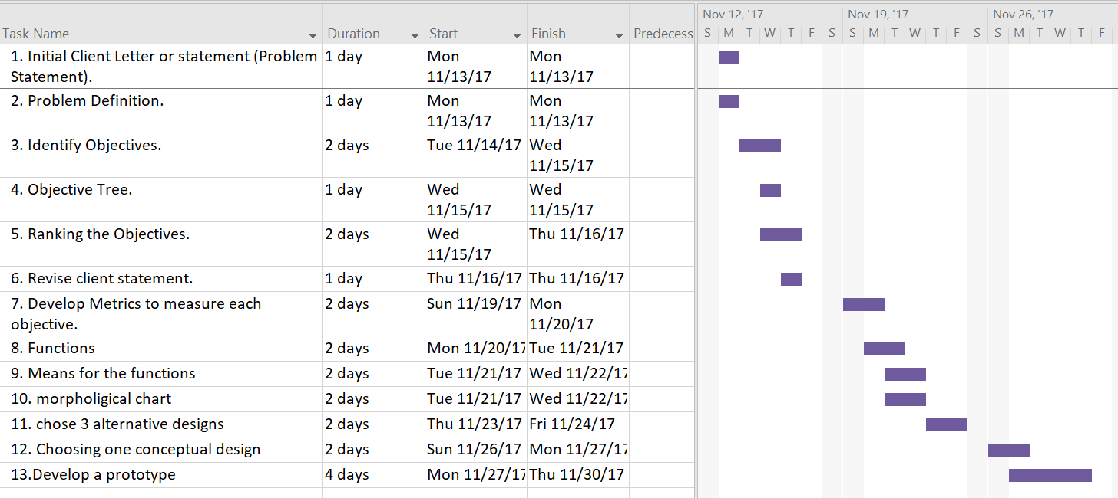
Gant chart:

The chart above indicates a series of horizontal lines which shows the amount of work done and the production completed in the periods of time specified and relates them to the amount of work planned for the periods.

3.02 Design methodology
In this project, we can up with a machine that has 3 cleansers in 1 which are connected at the top of a triple water pump to always keep the cleansers wet and easy to clean the clean shelves and tall buildings. It has a long iron stick welded on the steam iron, which is the bottom of the machine. The long iron stick is attached to a feather broom for cleaning dirty areas. The machine extends 3 meters and at least 1 meter in its height. The objective of devising the cleaning machine is to have easy access to inaccessible surfaces. After testing the cleaning machine, it functioned as expected, though it was a bit challenging to move it with the electric cable and hard to rotate it in high levels.

3.03 Final Design
The final design adopted will comprise of an automatic demo for rotating and a durable battery will be bought to replace the electric cable so that there can be ease of movement by the cleaning machine in high surfaces and roofs of tall buildings.
Below is the proposed cleaning machine with a steam iron at its base, a long iron stick to enable reach to higher surfaces and a feathery broom at its top for sweeping dirty areas.
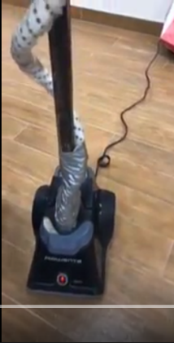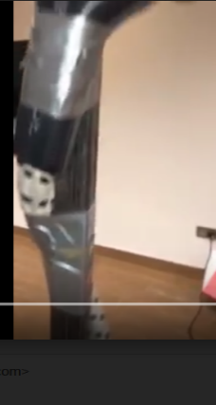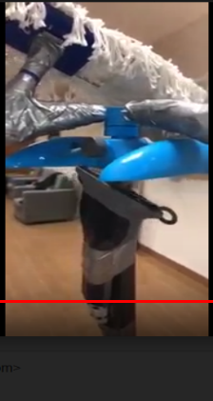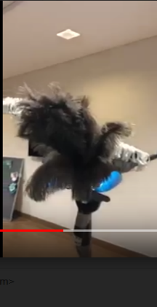
Proposed cleaning machine

4.0 Implementation
The project will be made effective by the team members. They are inventors of the cleaning machine and will plan and decide the best way to execute their plan.

4.01 Team Charter

4.011 Purpose Statement and team objectives
The project comprises a team of 5 members namely: Lamya Alameeri 1089, Alyazia Alrashed 0625, Khawla Almujaini 9495, Mariam Almarzooqi and Shaikha Alabdouli 9479. This team has been formed to design a duster for inaccessible surfaces in tall buildings. The objectives are to master materials related to this task and depict masterly of the final report and presentation. The team is committed towards the success of the project through working together in an effective way by monitoring the progress of the project and helping one another in understanding and learning the concept.
4.012 Strong areas and developmental gaps
In the determination of the project’s goals, the team examined the skills of the individual project members in relation to the ongoing task. In doing so, background experience and complementary skills of the individual team members were identified hence the easy definition of the individual levels of responsibility and accountability.

4.013 Strengths
The team is highly interested in human performance, ergonomics, safety and mechanical design. This will help in the project strategies and in the decision making process. Further, all the team members have a good background in engineering design hence the realization of the team’s goal will be easy. The team members also have a good experience in engineering design. In addition, the team members have excellent interpersonal skills which will aid in the success of the project, for members freely interact with one another and relate well, so airing of issues and concerns will not be a great deal for them. The team has a good mix of talents and skills with everyone participating and no dominating by any of the members. Turn-taking in the team discussions is evident through active contribution of all the team members.

4.014 Development Needs
The team portrays an understanding of the human performance which will help effective completion of the project. Even though it is not their area of expertise, they have countered this challenge through studying related literature and information in the discipline and have integrated the knowledge with their own experiences and best judgment.

4.015 Functional Roles
Lamya Alameeri 1089- tasked with buying a triple water pump
Alyazia Alrashed 0625- was assigned the duty of bringing a local steam iron
Khawla Almujaini 9495- was tasked with buying a long iron stick
Mariam Almarzooqi- was tasked with bringing a feathery broom
Shaikha Alabdouli 9479- was tasked with collecting all the materials brought by the members

4.016 Team Process Management
The team meetings are always guided by a SPACER (Safety, Purpose, Agenda, Code of conduct and Expectations). The team is always wary of exit points in case of an emergency and its meetings are guided by a purpose, and agenda desired outcomes and a code of conduct. The code of conduct entails arriving in time, sticking to the agenda of the meeting, no sidebars and one member speaks at a time. The expectation levels are always set before the start of any meeting.

4.017 Decision Making Process
In making its decisions, the team always solicit recommendations from professionals in engineering design, holds open discussions on the topic soliciting opinions from the individual members and allows feedback on unresolved issues related to the project topic. It responds promptly from inquiries from team members and in the event, a member is unable to deliver as required, they are expected to air the matter to the team members so that an alternative is made early in advance.

4.018 Process Roles
The team has standardized process roles as shown below:
- A team leader- ensures the achievement of the agenda, leads the team’s discussions, ensures delegation of tasks and summarizes key meeting expectations.
- Project monitor- ensures resolution in differing viewpoints and checks the team members to adhere to the set guidelines
- Timekeeper- tracks use of time in relation to the discussion topics
- Secretary- Writes minutes and keeps records of the meeting outcomes and activities.

4.019 Team Expectations
The team expects all members to attend meetings, fully participate in the project agenda and show general courtesy and respect.

4.0110 Assessment of Team Success
The team checks its progress after completion of a certain task. It conducts an evaluation of their work at the end of every meeting. It also checks whether every member performs according to the set code of conduct and guidelines. In doing so, the realization of the team’s success will be easy.

5.0 Testing Results
After testing the cleaning machine, it performed as expected, though there were challenges in moving it along the surfaces due to the restriction of the electric cable. It was also hard to rotate it in high levels. Cleaners really loved the innovation, they said that it would be able to solve their problem of cleaning inaccessible surfaces. The team members recommended replacing the electric cable with a long-lasting battery from the shops to make the movement of the machine flexible. They also opted to use the automatic demo to aid the rotation of the machine's top area.

6.0 Discussion
The machine proved to solve the problem of cleaning inaccessible surfaces despite its limitation in movement. However, through the use of a long-lasting battery, it will be able to surpass the dilemma of cleaning inaccessible surfaces in tall buildings either on horizontal or vertical surfaces. The ethical considerations that were put in place include a having in place a code of use for the cleaning machine for safety purposes during the testing of the equipment. The team also availed information on how the machine should be used to make the users aware of how the machine works and also keep them alert in case of an emergency. Further, the team asked for permission from the Institution to test the machine.

7.0 Conclusion
This project aimed at designing and prototyping a way of cleaning inaccessible surfaces in tall buildings. It comprised a team of five members who were assigned to different roles and functions towards the realization of the project's success. The team came up with a cleaning machine with 3 cleaners in 1. The machine was made using a long iron stick embedded on a steam iron box which was the base of the machine. It was connected to a triple water pump to ensure the supply of water. Another component of the machine was the feathery broom at its top to sweep dirty surfaces. The machine had the steam to make the selected cleanser wet and easy to clean the shelved and high levels in tall buildings. However, after it’s testing, movement of the machine was restricted by the electric cable and also it could not rotate well at high levels even though it functioned as expected. The team members resolved at purchasing a long-lasting battery from the shops to make the movement of the machine flexible. They also used a demo at its top to aid its rotation on higher levels.

References
Ceccarelli, M. (2012). Service robots and robotics: Design and application. Hershey, PA: Engineering Science Reference.
Lowe, Jean R. 2003. Ethics in engineering design: proceedings of the 1st Design Education Special Interest Group of the Design Society (DESIGN) Annual Design conference and 10th International Conference on Product Design Education, 10th - 11th September 2003, Bournemouth University, Bournemouth, UK. Bury St. Edmunds [u.a.]: Professional Engineering Publ.
"Team Charters: What Are They?". 2018. Lce.Com. https://www.lce.com/Team-Charters-What-are-they-1219.html.

(Ceccarelli, 2012)
(Ceccarelli, 2012)
("Team Charters: What Are They?" 2018)
("Team Charters: What Are They?" 2018)
("Team Charters: What Are They?" 2018)
(Lowe, 2003.)

